**Name: Muhammad Usamn**

**Roll No: 22i-0900**

**Section: BSCS-D**

**Task 1**

for 130 & 135

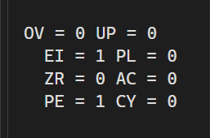

For 32767 & 32768

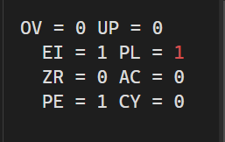

**Task 2**

19 from 25



125 from 125



155 from 14



**a). Use a loop statement using the LOOP Keyword to store all the values of multiples of 2, from 0 -&gt; 20 , in an array; by saving an appropriate integer value , in the counter register .**

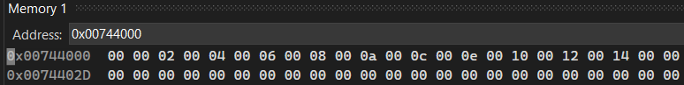

**Task 3**

a. 5 power 6

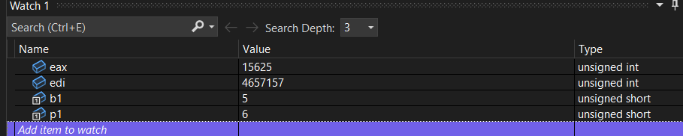

b. 4 power 5 + 8 power 4

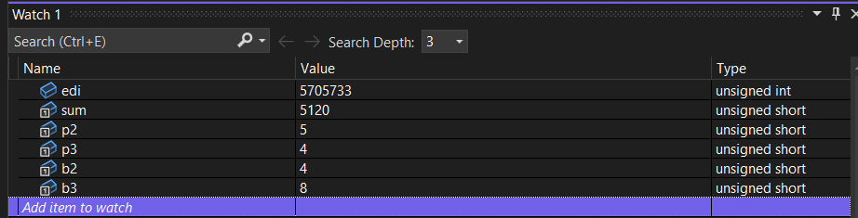

**Task 4**

Total loop count will be 5 so in each loop the value of eax increases

1st loop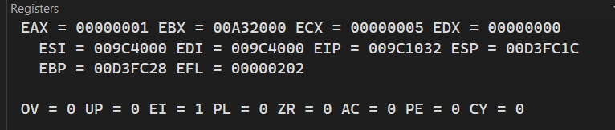

2nd loop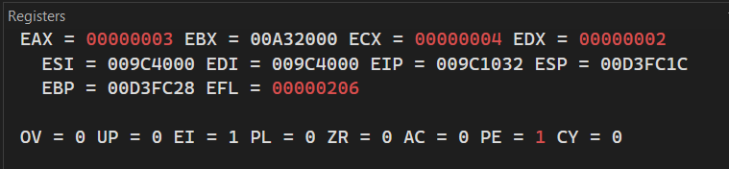 3rd loop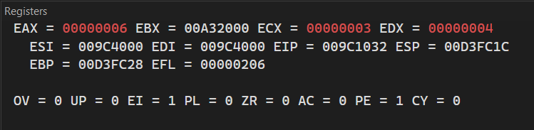 4th loop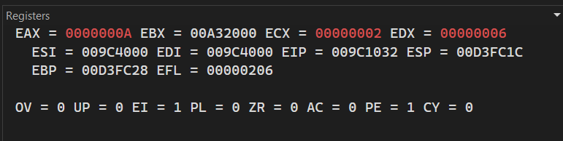 5th loop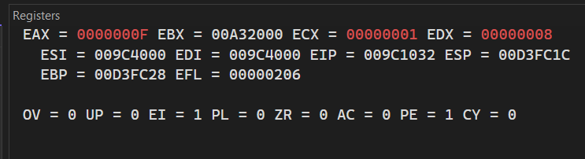Final Output in eax

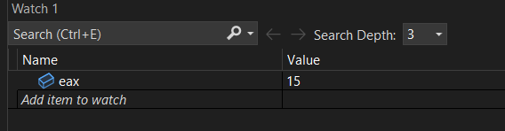

**Task 5**

2x4x6x8x10 .

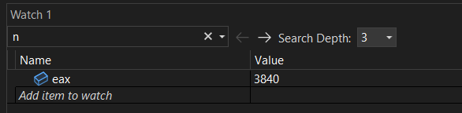

3x7x11x15x19 .

